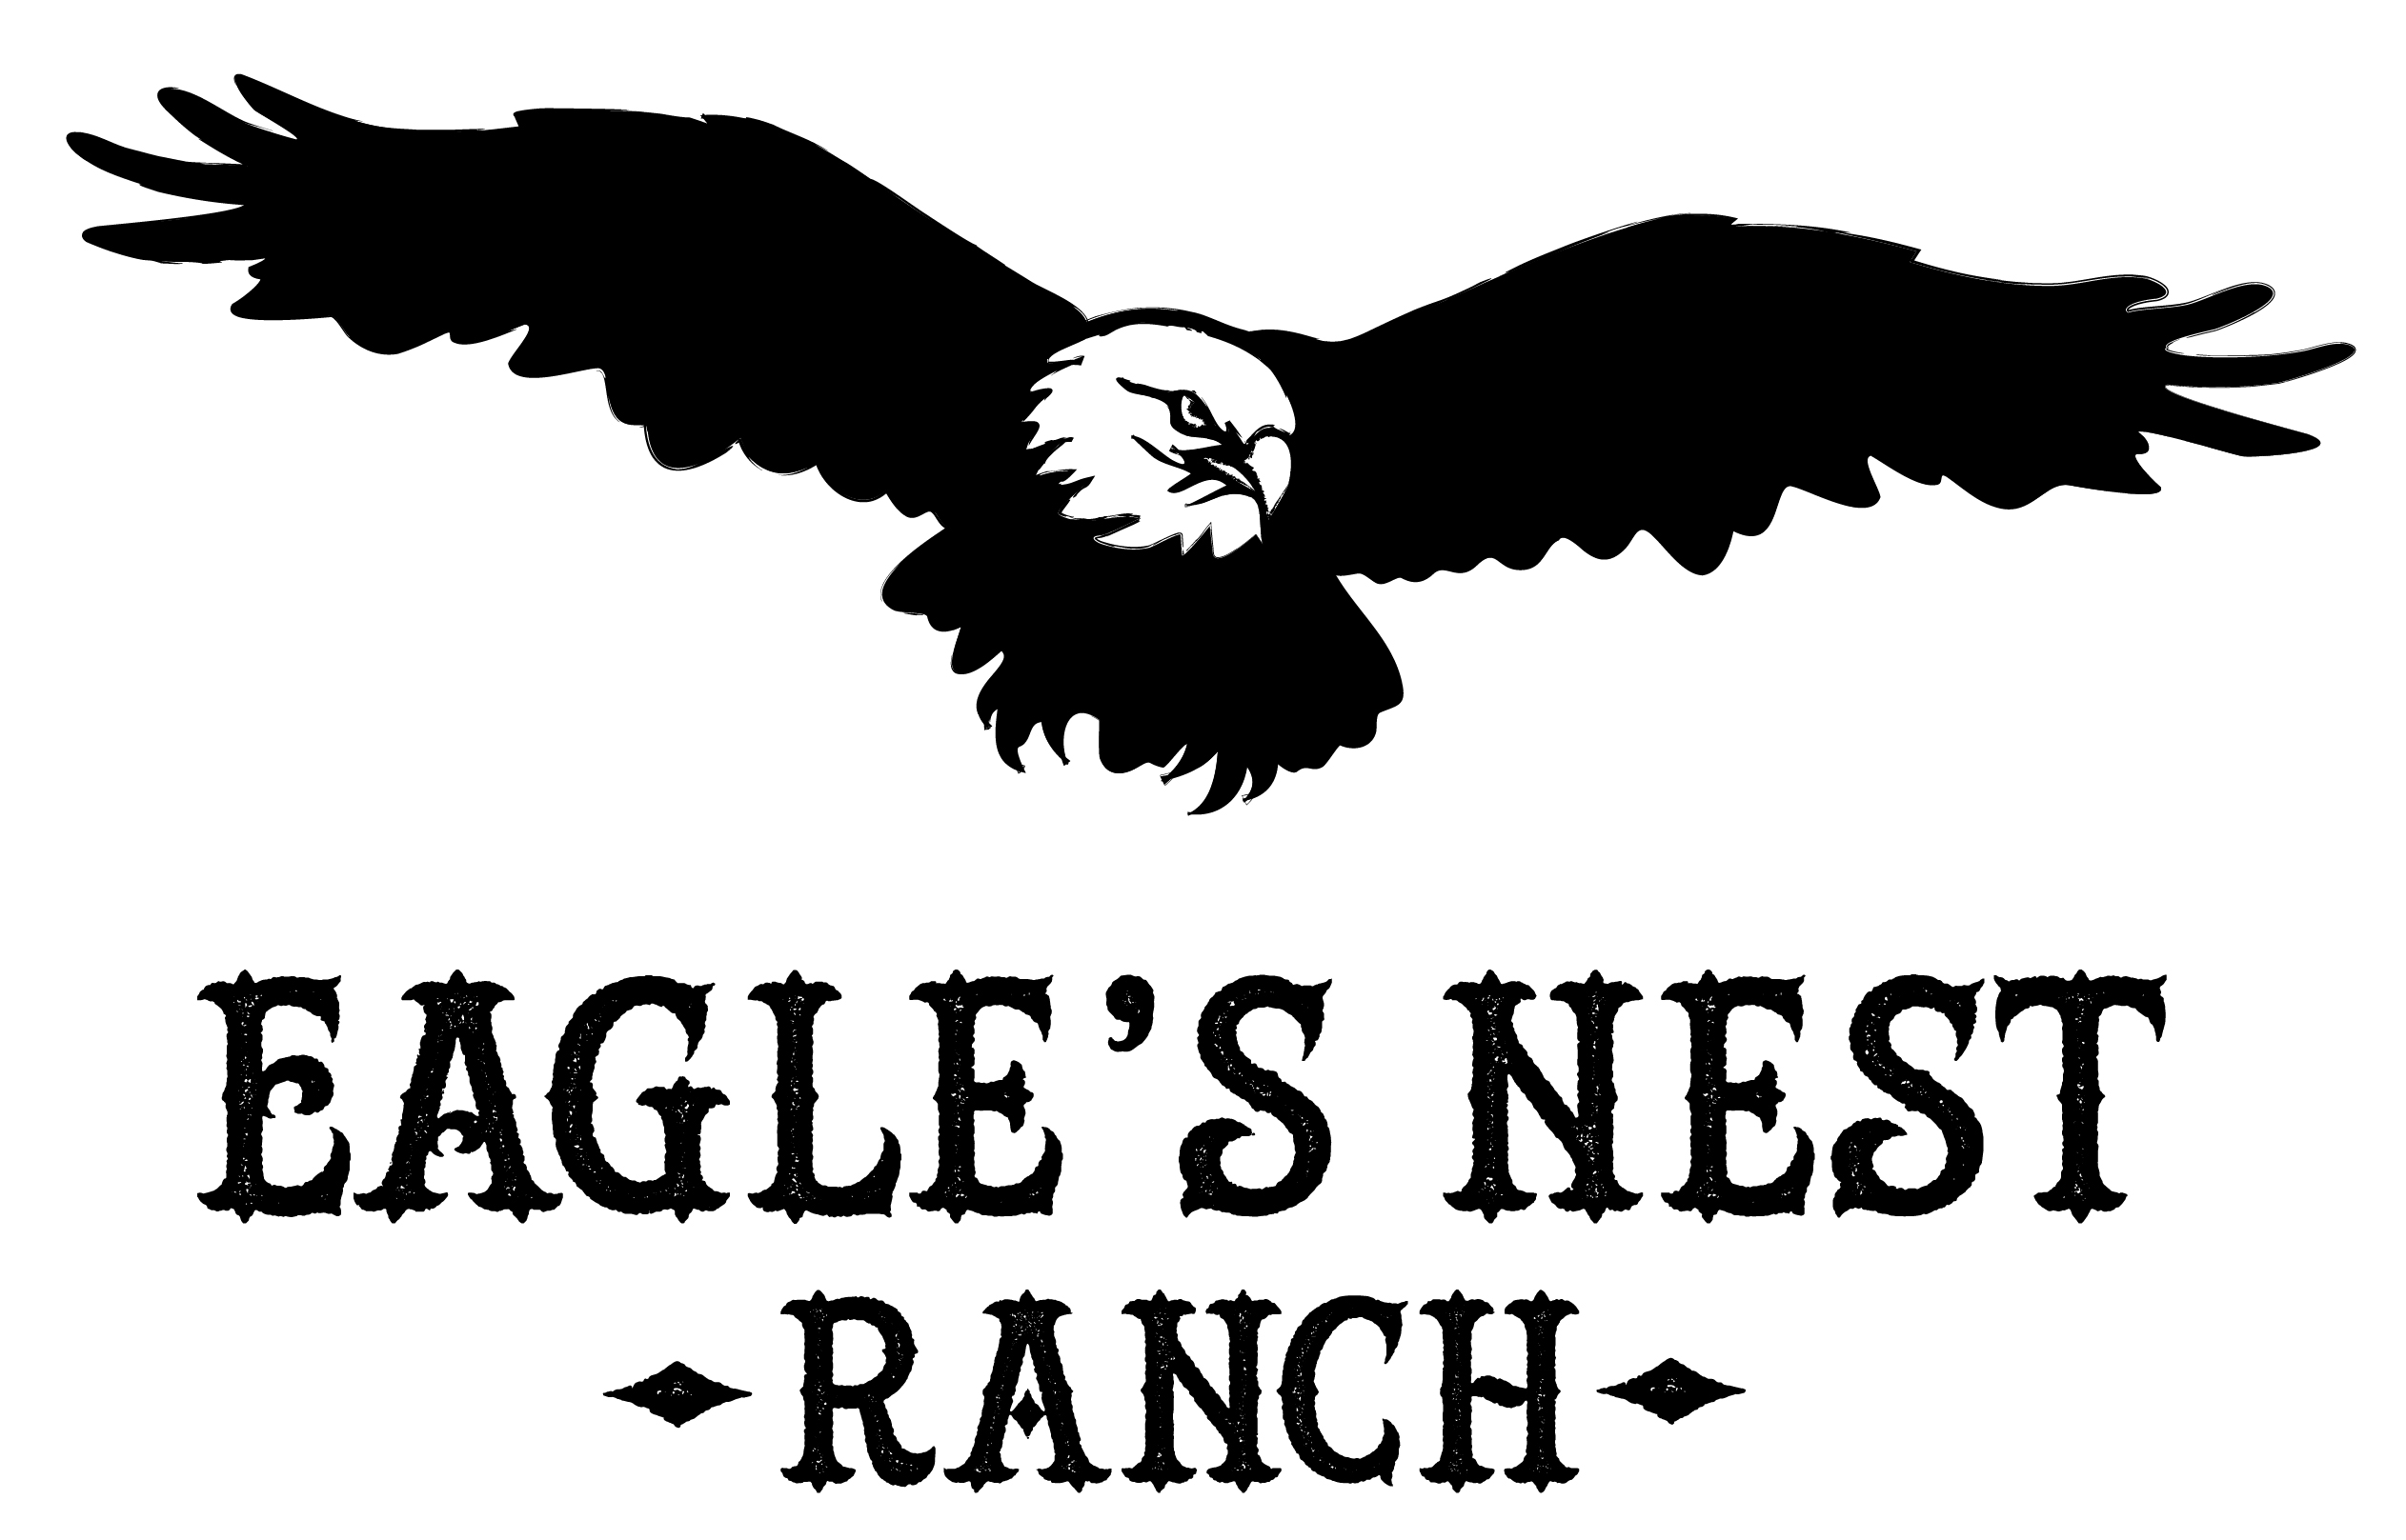
Eagle’s Nest Ranch
12264 Tenderfoot Trail,
Parker, CO 80138
303-596-2784
eaglesnestranch501@gmail.com

Volunteer Application Form

Name ______________________________________________________Sex ________ DOB _______

Mailing Address ______________________________________ City __________________ Zip_____________

Street Address ___________________________________________City ______________Zip____________

Email ______________________________ Home Phone _________________ Wk Phone_________________

Cell or Other contact number _________________________ Employer/School _____________________________

How did you hear about Eagle’s Nest Ranch?________________________________________________________

Why are you interested in volunteering at Eagle’s Nest Ranch?__________________________________________

____________________________________________________________________________________________

Volunteer Information Form

In what areas would you like to help out at Eagle’s Nest Ranch?
Please check all that apply:
______ Fund Raising: fund raising projects and ideas and ways to help fund the ranch
______ Special Events – planning and implementing
______ Grant Writing and research
______ Administrative – data entry, phone calls, records of horses, volunteers, participants, etc
______ Assistant – make phone calls, run errands, etc.
______ Family greeter, welcome, tour guide
______ Graphic design, publications, flyers
______Photographs, Videos, Web Site, technology
______ Marketing/Public Relations
______ Ranch prayer team – pray for needs of the ranch, meet for prayer, etc.
______ Ranch maintenance – repairs, mending fences, ranch chores, etc.
______Green thumb – landscaping, mowing, grounds maintenance
______ Food/snacks
______ Volunteers: Coordination and retention of volunteers; volunteer appreciation
______ Horse handler/Care: grooming, holding for vet/farrier, bathing, tack room organization, mucking
______ Horse training – desensitization, ground work, ground manners, riding
______ Mentor/instructor –work with the participants with a horse
______ Other _________________________________________________________________

How often do you anticipate volunteering for the ranch ______ weekly _______ monthly ________ quarterly?

Which days of the week are you available? _______________________________________________________

Which times work best for you? ________________________________________________________________

Have you ever volunteered with a horse ranch program? ___ Yes ____ No

If yes: What program and in what capacity?__________________________________________________________

In what areas do you feel you are qualified to volunteer with horses?
____ Horse handler (horse experience required; prepares horse for class; primary focus during class is the horse)
____ Office Help (flexible hours; filing, organizing, preparing mailings, help with computer upgrades, etc.)
____ Horse care (flexible hours; worming horses, holding horses for the farrier, mucking, grooming etc.)

Horse Experience ____ None ____ Minimal ______Moderate _____ I have owned or currently own a horse.

Describe your horse experience:_______________________________________________________________

_________________________________________________________________________________________

I can ___ halter a horse unassisted ______ clean horses hooves unassisted ______ saddle a horse unassisted

Do you have any special skills, talents, or abilities that would be helpful to Eagle’s Nest Ranch?
_____________________________________________________________________________________________
_____________________________________________________________________________________________

Does your employer have a matching gifts program for ______ Volunteer Hours ____ Cash Donations?

Within your circle of influence, is there anyone who is a possible candidate to volunteer or provide financial
Assistance or help in another way? _____ Yes _____ No

Would you be willing to contact them on Eagle’s Nest Ranch’s behalf or introduce us to them? ____ Yes _____ No

Please list two Personal References other than family:

Name _______________________________________Relationship________________Phone__________________

Name_______________________________________ Relationship _______________Phone__________________

Have you ever been arrested for, or convicted of, a crime against a person or animal?________

Have you ever been listed on a registry for child abuse?________

I have answered truthfully and accurately. I understand that Eagle’s Nest Ranch will run a Colorado background check. Eagle’s Nest Ranch will guard my information and privacy.

____________________________________________ _________________________
Volunteer Printed name Date

___________________________________________
Volunteer Signature

